**Copy class and lib folders to Desktop** (important for file paths) and run the **Get_Rg.py** script (i.e. in spyder),

1st window pops up asking for a .jpk.asc file:

* Browse and select your file or use the provided ‘Example.jpk.asc.’

Next set of windows show identified molecules:

* Click (with mouse) inside the window to **accept** a molecule.
* Press **Enter** (button) to **decline** (trash it).

On Mac:

* Program crashes after molecules have been sorted, **force quit Python.**
* Excel file with Rg values is saved to Desktop (some columns 0 due to original nucleosome part of code).
* Using a NTFS hard drive on mac seems to bypass this crash...

On Windows:

* **NTFS/Windows PC (Windows users please let me know if it works for you)** individual molecule images are saved as .asc files e.g.

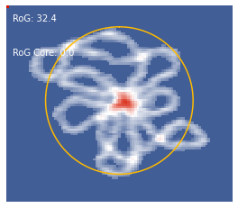

Troubleshooting:

* Ensure Python and all packages are installed and updated (in terminal).
* Place class and lib folders on Desktop.
* Use a .jpk.asc file.
* Mac users: Check Desktop for the Excel file if program crashes.

